HC Flow Meter Written Specifications
Part 1 – General
- The simple-to-install HC Flow Meter allows customers to monitor flow rates and system hydraulics with Hydrawise-enabled controllers. When connected to the Hydrawise Irrigation Management Platform, the HC Flow Meter provides a convenient option to detect, monitor, and report critical flow zone data and total system flows. Better yet, when hardscape materials get in the way, add flow monitoring capabilities to Hydrawise smart irrigation systems quickly and easily with the optional Wireless HC Flow Meter Communication Kit.
Part 2 – Hardware
- The HC Flow Meter is for use with Hydrawise-enabled irrigation controllers and is available in both wired and wireless configurations.
  - HC Flow Meter
    - Brass construction with union fittings for quick installation and removal.
    - Analog dials with PVC cover on the face of the meter allows for manual flow readings and leak detection – US Gallon and Metric units available.
    - Inlet Pipe Sizes
      - US models – male threaded NPT fittings; ¾", 1", 1 ½" and 2"
      - Int’l models – male threaded BSP fittings; 20-, 25-, 40- and 50-mm
    - Electrical Connection to Controller
      - Wire harness coming from the HC Flow Meter contains three wires (red, white, and blue). Only the blue and white wires are used for connection to the controller. The unused red wire should be capped with a waterproof splice.
      - Shielded cable is required. Meter can be installed a maximum 1,000' (300 m) from the controller using 18 AWG (0.75 mm²) shielded wire.
    - Flow Meter Register
      - Reed Switch, Scaled-Pule output
      - Scaled-pulse output is pre-calibrated from the factory based on inlet pipe size of the meter. See specifications below.
    - Flow Meter Installation
      - Must be installed horizontally with the dial facing up.
      - Flow meter body has a directional arrow indicating proper orientation of flow through the meter.
      - To ensure accurate flow readings, the meter must be installed with uninterrupted straight pipe before and after the meter. At least 10x inlet diameter and 5x outlet diameter is required to prevent turbulence within the pipes (i.e., 1" HC Flow Meter requires at least 10" of straight pipe before the meter and 5" of straight pipe after).
      - Meter must be removed or bypassed to perform winterization.
  - Wireless HC Flow Meter
    - Wireless Communication Kit for use with any size HC Flow Meter
    - Send station-level flow rates and totals wirelessly from the sensor to the controller, without the need to run wire or dig trenches.
    - Wireless HC Flow Transmitter
      - Battery-powered transmitter (3 x AA included) connects to the HC Flow Meter in the field to detect and communicate flow rates and totals.
      - 3 ¼" (8.25 cm) diameter thread body installs through the valve box lid.
      - Wire harness coming from transmitter has a white and blue wire for connection to white and blue leads coming from HC Flow Meter. Splice wires together using included waterproof connectors.
    - Wireless HC Flow Receiver
      - Receiver is powered by the host controller (24 VAC) and transfers flow data from the meter/transmitter to the controller and cloud software.
      - ½" (12.5 mm) diameter thread body installs through any conduit knockout within the controller enclosure.
      - Wire harness coming from the receiver has two yellow wires for connection to 24 VAC power, and one white and one blue wire for connection to the Sensor/Sensor Common terminals.
      - Receiver can be extended to improve line-of-sight communications, for a maximum distance of 25' (7.6 m) from the controller using 18 AWG (0.75 mm²) wire.
  - Compatible Controllers
    - Hydrawise-enabled HC, HPC, Pro-HC, and HCC Controllers
Part 3 – Software
- Controller must be connected to the internet and linked to a Hydrawise account to enable flow monitoring capabilities.
  - By connecting directly to Hydrawise software, the HC Flow Meter is used to automatically monitor, detect, and report alerts for critical flow zone data. This helps users know exactly how much water they’re using, or potentially losing, during irrigation. Additional capabilities include:​
    - Total system flow monitoring
    - High and low-flow alerts and push notifications
    - Station-level flow rates and totals
    - Total system water use reporting
    - Leak detection

Part 4 – Specifications
- HC Flow Meter operating specifications for wired and wireless configurations.
  - HC Flow Meter
    - Scaled pulse output is pre-calibrated from the factory based on the size of the meter.
    - Max. wiring distance: up to 1,000' (300 m) from the controller.
      - When wired directly to the controller, the meter must be installed with shielded, minimum 18 AWG (0.75 mm²) wire.
    - Accuracy: +/- 2% of reading at recommended flow rates
  - Wireless HC Flow Meter
    - 500' (152 m) wireless range from transmitter to receiver (line of sight)
    - Communication frequencies:
      - US Model: 900 MHz
      - International Model: 868 MHz
      - AU/NZ Model: 915 MHz
    - Transmitter Power Supply: 3 AA batteries
    - Receiver Power Supply: 24 VAC from host controller
  - Pressure and Flow Specifications
    - US Gallon Reading
 | HC-075-FLOW  (¾") | HC-100-FLOW  (1") | HC-150-FLOW (1 ½") | HC-200-FLOW (2")
Min. Flow Rate (GPM) | 0.22 | 0.3 | 0.88 | 1.98
Max. Recommended Flow (GPM) | 15 | 30 | 66 | 105
Max. Flow Rate (GPM) | 21 | 34 | 88 | 132
Max. Working Pressure (PSI) | 230 | 230 | 230 | 230
Dial Reading | 1 pulse per 0.1 US Gallon | 1 pulse per 1 US Gallon | 1 pulse per 1 US Gallon | 1 pulse per 1 US Gallon

    - Metric Reading
 | HC-075-FLOW-B  (20 mm) | HC-100-FLOW-B  (25 mm) | HC-150-FLOW-B  (40 mm) | HC-200-FLOW-B  (50 mm)
Min. Flow Rate (l/min) | 0.83 | 1.16 | 3.33 | 7.5
Max. Recommended Flow (l/min) | 60 | 110 | 250 | 400
Max. Flow Rate (l/min) | 80 | 130 | 330 | 500
Max. Working Pressure (Bar) | 16 | 16 | 16 | 16
Dial Reading | 1 pulse per 1 litre | 1 pulse per 10 litres | 1 pulse per 10 litres | 1 pulse per 10 litres

  - Pressure Loss
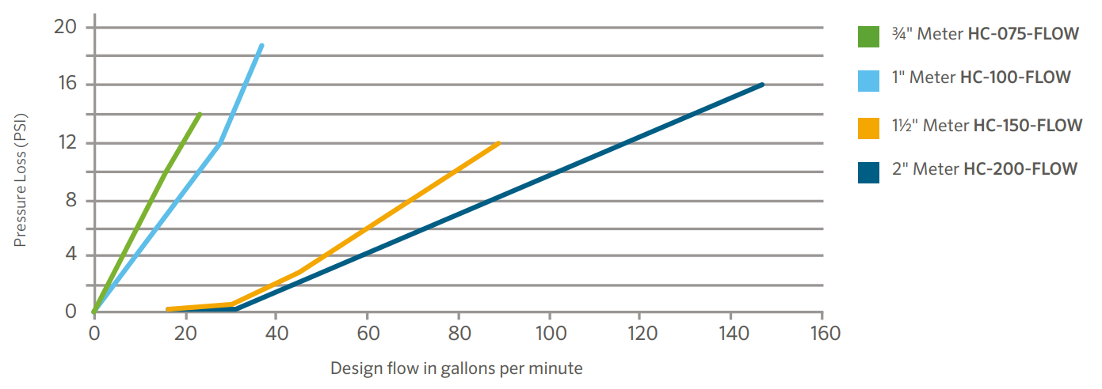
    - US Gallon Reading
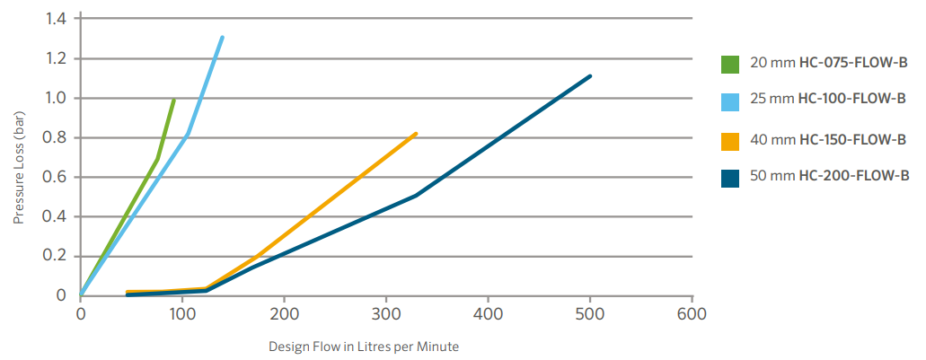
    - Metric Reading
Part 5 – Models
- All components of the system shall have a two-year manufacturer’s warranty.
  - The HC Flow Meter shall be Hunter Industries Model:
    - US Gallon Reading
      - HC-075-FLOW
      - HC-100-FLOW
      - HC-150-FLOW
      - HC-200-FLOW
    - Metric Reading
      - HC-075-FLOW-B
      - HC-100-FLOW-B
      - HC-150-FLOW-B
      - HC-200-FLOW-B
  - The Wireless HC Flow Meter Communication Kit includes both a transmitter and receiver, and shall be Hunter Industries Model:
    - W-HC-FLOW
    - W-HC-FLOW-INT
    - W-HC-FLOW-AU
  - Spare replacement parts are available for the Wireless HC Flow Meter Communication Kit and shall be Hunter Industries Model:
    - Transmitter Only
      - W-HC-FLOW-TR
      - W-HC-FLOW-TR-INT
      - W-HC-FLOW-TR-AU
    - Receiver Only
      - W-HC-FLOW-R
      - W-HC-FLOW-R-INT
      - W-HC-FLOW-R-AU

